3-1 Journal: Explore Modular Programming
Real-world scenario: the purchase of stock
A real-world scenario that would involve the use of modular programming is purchasing of stock from a brokerage account. This example was first examined in Journal 2-1 and it will be built upon to demonstrate the improvement to the code previously written because of the implementation of modular programming.
Implementation of modular programing in scenario:
In this scenario the user is given the option to purchase stock from three different companies (Disney, Netflix, and Comcast). In the previously written code, the calculation of the maximum numbers of shares that could be purchased based on the user’s investment budget and the total purchase cost was written once and then copied and pasted to the other conditional branches. Then the calculation for the updated account balance after the stock transaction was written for each investment type, (see Figure One lines 30 through 73). However, when functions are utilized, the code can be written once and then referenced as needed to the various subsequent sections of code (see Figure Two lines 2 through 11, 51, 60, and 61). The main calculations were broken down into three main functions: maximum stock shares (the maximum number of shares that could be purchased based on the investment budget), investment cost (the total cost of the purchase of confirmed stock shares), and updated account balance (remaining account balance after the confirmed purchase was made).
Improvement of code organization by modular techniques in scenario:
The improvement to the code readability and length is evident between Figure One and Figure Two and the length of the code was reduced from 82 lines to 72 lines based solely on the use of modularization. The code in Figure One, which was written without modular programming, is much harder to follow since the reader must re-read the same portions of code over again for each investment type option.
Explain how modular programming can benefit developers. Consider the following:
Readability: the readability of the code is enhanced by modular programming since the redundancy of the code is no longer present; therefore, the reader doesn’t have to re-read portions of the same code over again and determine if the logic is still correct and examine it for small accidental changes or for updating (in this case making sure the reference is made the correct type of stock: Disney, Netflix, or Comcast) that must be done when copying and pasting code.
Reusability: the use of functions in programming allows the writer to easily reference previously defined formulas via functions. The writer can reuse this calculation formula without having to copy the formula from a previous section of the code to what they are currently working on.
Testing and debugging: a function can be tested once when it is first written and then can be referenced throughout the piece of code allowing the writer to only need to test that function once and not have to copy and paste its contents throughout the code; this allows for more efficient testing and debugging.
Maintenance: as the need for changes to code arises, modularization allows for more efficient changes to the code. An example would be the changing of the print output of a given code, like adding a period to the end of sentence that is printed. If modulization is used the output can simply be updated once in the definition section of the function code. If a function has not been used this change would need to be to be to each variable which could lead to potentially hundreds of manual updates being needed.

Discuss any challenges that could arise when using modular techniques and what steps you would take to mitigate them:
The use of modularization is efficient if the initial design of the code output is well thought out prior to writing the program code. It requires a high-level view of how the code will function as well as a detailed understanding of how the repetitive portions that can be coded as functions. The use of flowcharts can assist the programmer with having a solid understanding of the entire program process prior to beginning to write the code, as it can be difficult to assess errors that appear when using previously defined functions. The flowchart will assist the programmer in determining which sections of the code can be reused and help in avoiding the copying and pasting of code. Once the functions have been written it is more difficult to determine the cause of errors as they can flow through several sections of code and several sections of code can be dependent on the initially defined functions. For example, it can be ambiguous whether the error is coming from the function itself or its subsequent reference later in the code. Overall, the user of modularization and functions may require more upfront time and planning to be effective, but the short-term cost is outweighed by the long-term benefits of code scalability, reusability, subsequent changes and maintenance.

Figure One: Python Code Example (without Modular Programming)
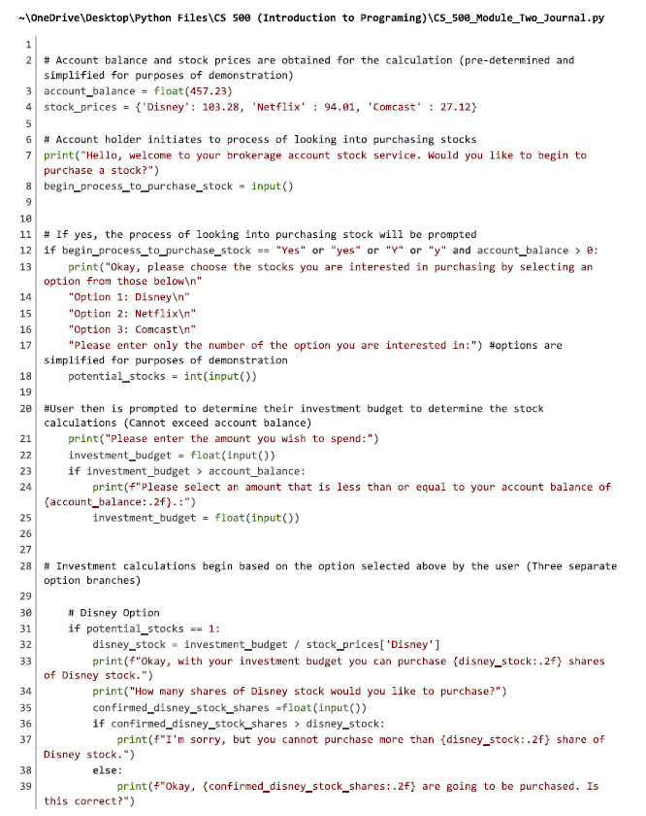

Figure One: Python Code Example (without Modular Programming)- continued
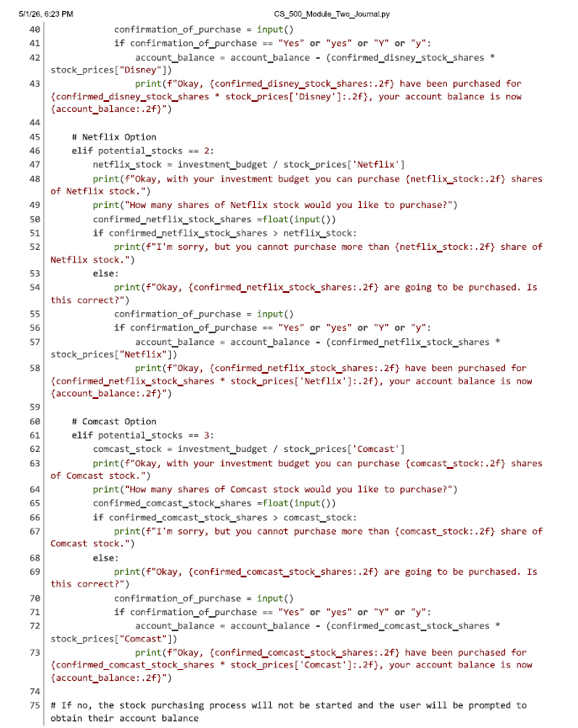

Figure One: Python Code Example (without Modular Programming)- concluded
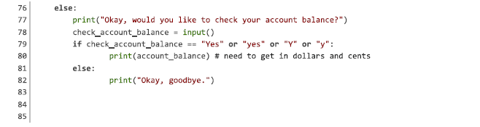

Figure Two: Python Code Example (with Modular Programming)
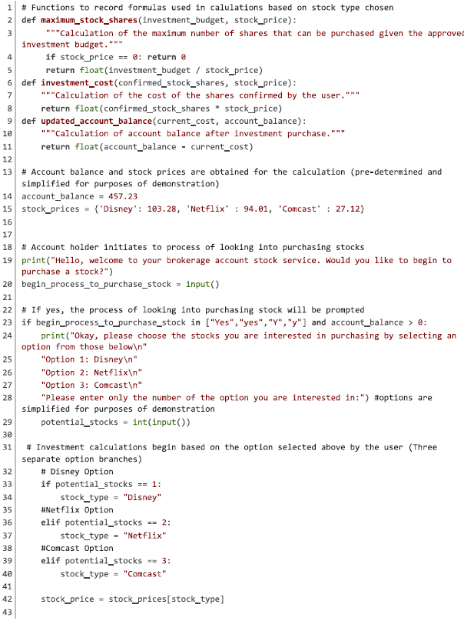
Figure Two: Python Code Example (with Modular Programming) – continued
